**Project 1 – Mohak Kant**

Filter Specification:

Filter Order: 6

Stages: 3

Gain: 10 V/V (20 dB)

Center Frequency: 1.2kHz

Passband Bandwidth: 120Hz

Stopband Bandwidth: 1kHz

Q = 10

The Circuit Schematic used is attached below. The circuit consists of a Bandpass filter followed by an envelope detector and a comparator.

Also, a voltage divider was used in conjunction to a buffer to use reference at Vcc/2. The bottom part of the schematic depicts the voltage follower used to generate reference.

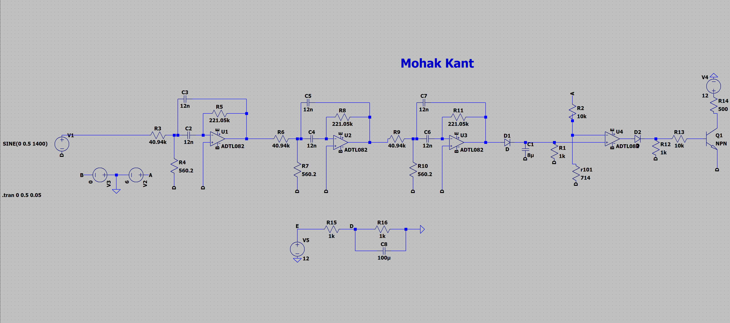

The Output waveforms are depicted below.

At 1Vpp:

1200 Hz: The output is near 0V depicting outband.

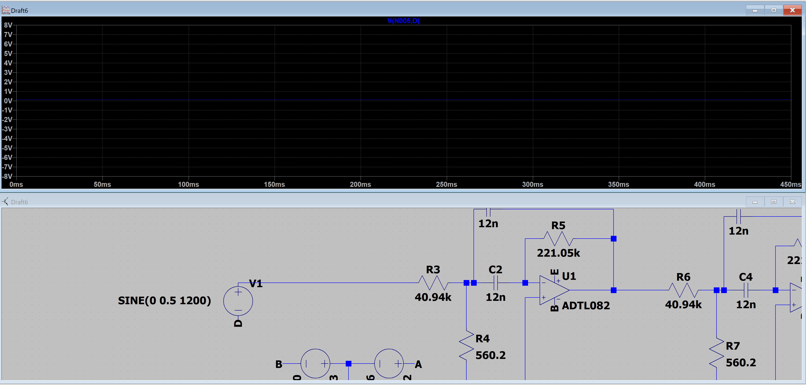

1320 Hz: The output is near 9.5V depicting outband.

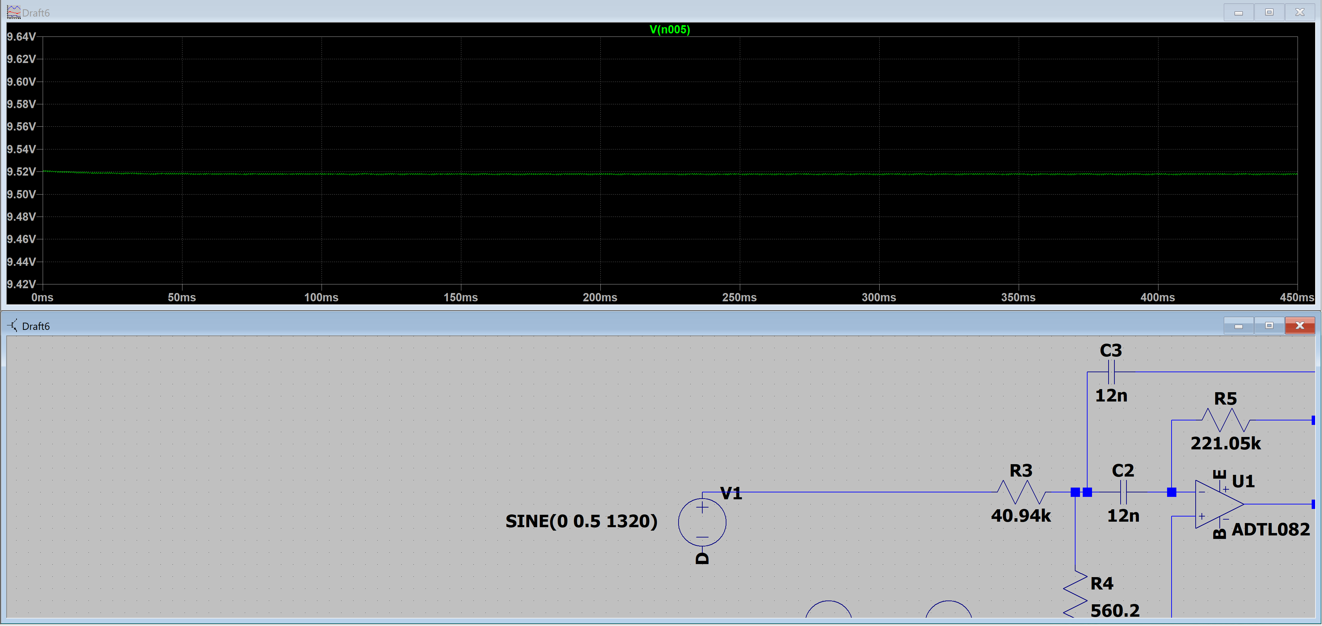

At 100mVpp:

1320 Hz: The output is near 9.5V depicting outband.

